ASSIGNMENT -4 (B)

1. Display prime numbers between 1 and 100 or 1 and n.

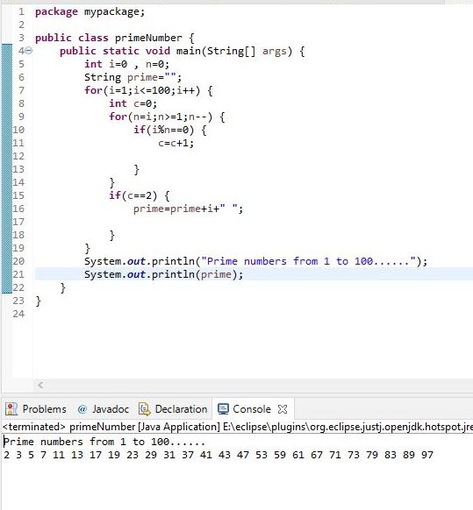

1. Check if a number is palindrome or not.

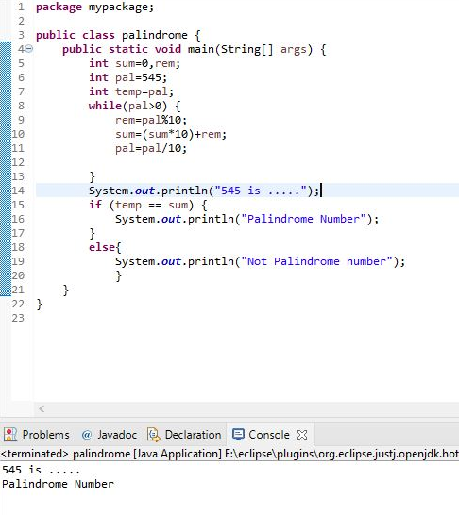

3.Find the square root of a number without sqrt method.

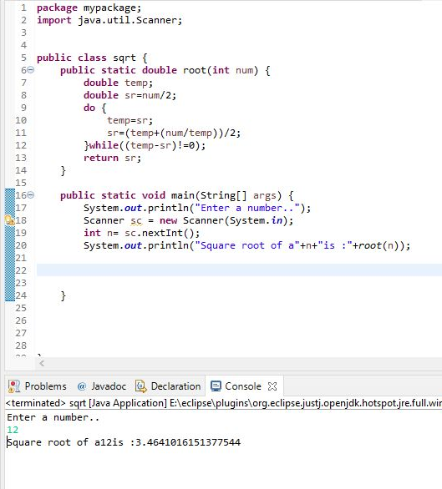

4.Calculate grades of students using their marks.

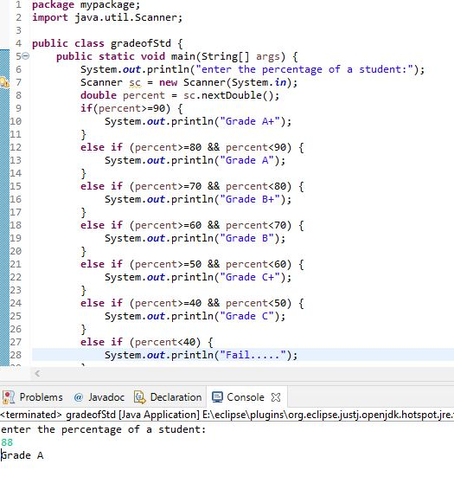

5.Use switch case, check 0 to 9 numbers.

